Iron Curtain
The Iron Curtain is a term used in the West to refer to the boundary line which divided Europe into two separate areas of political influences from the end of World War II until the end of the Cold War. During this period, Eastern Europe was under the political control and/or influence of the Soviet Union, while Western Europe enjoyed political freedom (see Free World). The term comes from a long speech by Winston Churchill on March 5, 1946 in Fulton, Missouri:
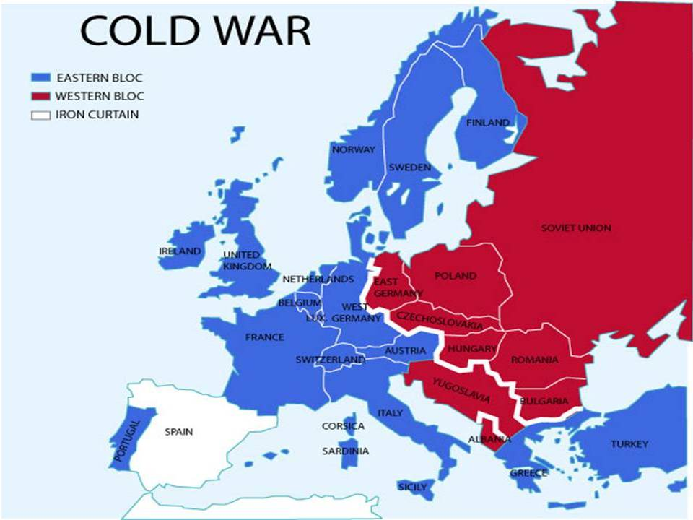
From Stettin in the Baltic to Trieste in the Adriatic an iron curtain has descended across the Continent. Behind that line lie all the capitals of the ancient states of Central and Eastern Europe. Warsaw, Berlin, Prague,Vienna, Budapest, Belgrade, Bucharest and Sofia; all these famous cities and the populations around them lie in what I must call the Soviet sphere, and all are subject, in one form or another, not only to Soviet influence but to a very high and in some cases increasing measure of control from Moscow.

Iron Curtain Rubric
- Title
- Date
- Picture
- Define the Iron Curtain in your own words
- What was the difference in the countries on the west side of the Iron Curtain to the east side? (Think government-who followed the Soviet Union?)
Division of Germany after World War II
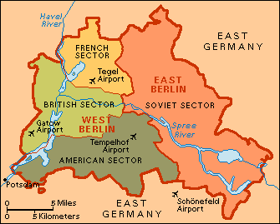

Germans frequently refer to 1945 as the Stunde Null (zero hour) to describe the near-total collapse of their country. At the Potsdam Conference, Germany was divided into four military occupation zones by the Allies; the three western zones would form the Federal Republic of Germany, while the Soviet zone became the German Democratic Republic, both founded in 1949.
This separation lasted until the end of the Cold War, when in 1989 the Berlin Wall fell and Germany was reunited on October 3, 1990.

Division of Germany after WWII Rubric
- Title
- Date
- Picture
- How was Germany separated?
- How long did the separation last?

Berlin Blockade

Blockading Berlin: The city of Berlin was an island in the middle of the Soviet controlled zone. The west sent supplies there via railroads and roads. However, the Soviets wanted total control of Berlin. They figured if they cut off Berlin from their external supplies and food, then it would fall under their control.
On June 24, 1948 the Soviets blocked all rail and road traffic to Berlin. They cut off the electricity coming from the Soviet part of the city. They halted all traffic going in and out of the city. The only way in was to fly.
The Berlin Airlift (1948-1949) was an action during the Cold War taken by the United States and neighboring Western European nations to airlift food and other necessities into a Communist-surrounded west Berlin. The American action was given the name Operation Vittles; the British one was called Plain Fare.
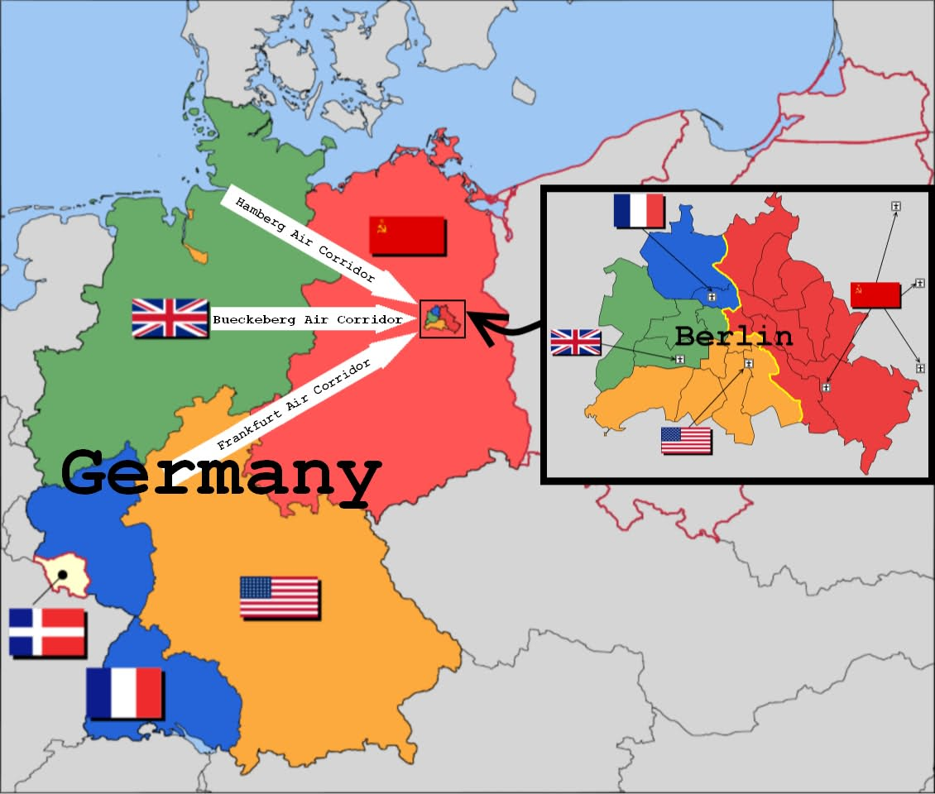
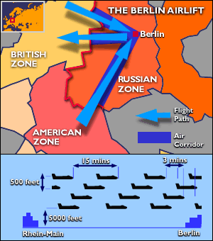
It was launched on June 26, 1948 after the Soviet Union started a land blockade of West Berlin on April 1, 1948. The USSR lifted its blockade at midnight, on May 11, 1949.
Berlin Blockade Rubric
- Title
- Date
- Picture
- Why did the Soviet Union block in Berlin?
- How did they block in Berlin?
- Why did the blockade NOT work?

NATO and the Warsaw Pact
The North Atlantic Treaty Organization (NATO) is an international organization for defense collaboration established in 1949, in support of the North Atlantic Treaty signed in Washington, D.C. on April 4, 1949.
This provision was intended so that if the Soviet Union launched an attack against the European allies of the United States, it would be treated as if it was an attack on the United States itself. However the feared Soviet invasion of Europe never came. Instead, the provision was used for the first time in the treaty's history on September 12, 2001 in response to the September 11, 2001 Terrorist Attack.
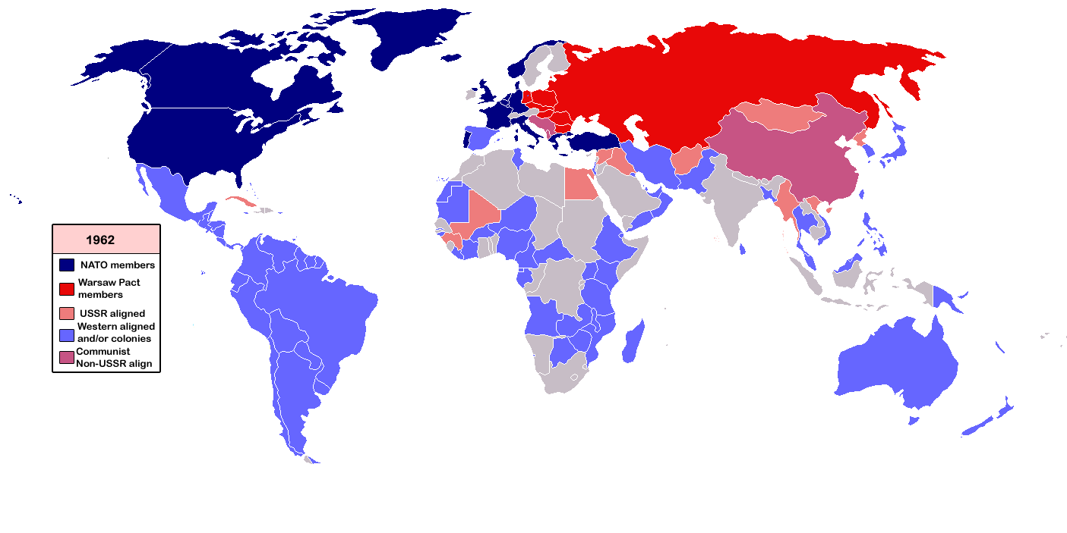
The Warsaw Pact was a military alliance of the Eastern European Soviet Bloc countries intended to organize against the perceived threat from the NATO alliance, established in 1949. The treaty was drafted by Khrushchev in 1955 and signed in Warsaw on May 14, 1955; its members were the Soviet Union, Albania, Bulgaria, Romania, East Germany, Hungary, Poland, and Czechoslovakia--all the Communist countries of Eastern Europe except Yugoslavia. The members of the Warsaw Pact were to defend each other if one was attacked. The pact came to an end on March 31, 1991 and was officially dissolved at a meeting in Prague on July 1.

NATO and the Warsaw Pact Rubric
- Title
- Date
- Picture
- Define NATO and why it was created.
- What is the Warsaw Pact and what countries were a part of it?

Cold War Space Race
The Space Race was a competition between the United States and the USSR in space exploration and technology, and especially to the race between the two nations to land a human being on the moon. Significant events:
- first artificial satellite - Sputnik 1 (1957, USSR)
- first animal in space - Sputnik 2 (USSR)
- first manned spaceflight - Vostok 1 (1961, USSR)
- first orbital flight - Vostok 1 (as above)
- first spacecraft on moon - Luna 2 (USSR)
- first orbital flight of moon - Apollo 8 (1968, USA)
- first human landing on moon - Apollo 11 (1969, USA)
The Soviets beat the Americans in most firsts, but did not manage to beat them to the moon. Technology and especially aerospace technology advanced greatly during this period. In the sense that it was contested during the 1960s, the space race is usually considered to have been ended by the joint Apollo-Soyuz mission [US/USSR MANNED MISSION] in 1975.

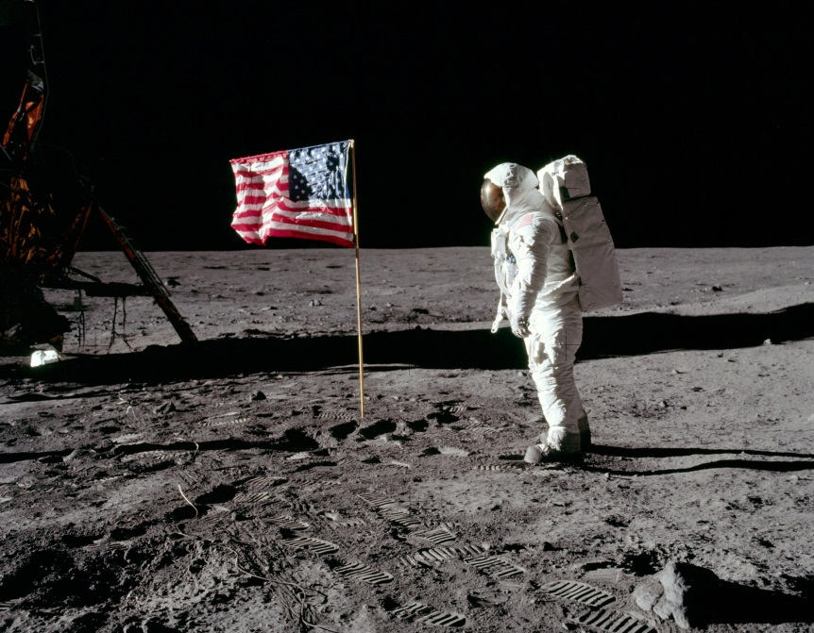
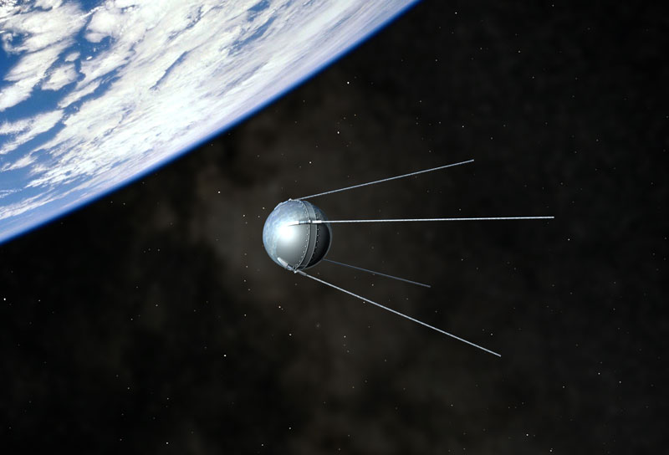
Cold War Space Race Rubric
- Title
- Date
- Picture
- What was the “Space Race?”
- Who won? Explain.

U-2 Incident
Flying the U-2 spy plane from Adana, Turkey to Bod, Norway a Soviet aircraft was shot down by a SAM (Surface to Air Missile) on May 1, 1960.
The Paris Summit between Dwight Eisenhower and Nikita Khrushchev collapsed, in large part because Khrushchev demanded an apology over the incident. Khrushchev had announced the shooting down on May 5 and American attempts to claim it was an off-course meteorological flight were embarrassingly destroyed when the Russians revealed they had captured the pilot.
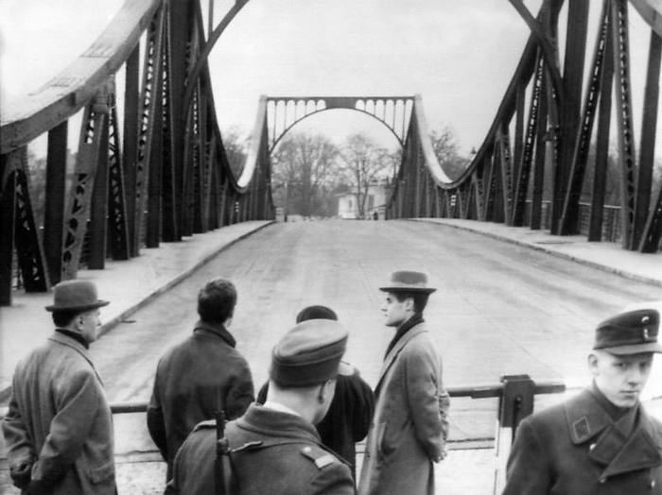
Powers, of the United States, was convicted of espionage on August 19 and sentenced to 3 years' imprisonment and 7 years of hard labor. He only served one and three-quarter years before being exchanged for Colonel Rudolph Ivanovich Abel on February 10, 1962. The exchange occurred on the Glienicke Bridge in Berlin.

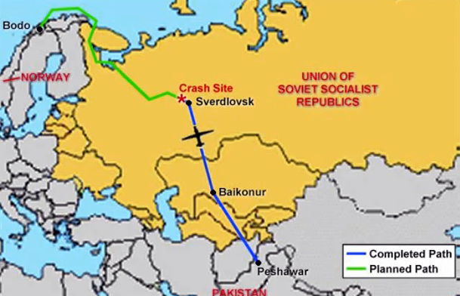

U-2 Incident
- Title
- Date
- Picture
- What country was shot down? What country shot down the aircraft?
- How was the issue resolved later on?

Cuban Missile Crisis
The Cuban missile crisis was the clash between the USSR and the USA over the Soviet deployment of nuclear missiles in Cuba. The crisis began on October 15, 1962 and lasted for thirteen days. After seeing that there were Soviet missiles on Cuban land, the United States cut off ways in which anything or anyone could get into or out of Cuba. In exchange for the United States removing missiles from other countries, the Soviet Union removed all missiles from Cuba.
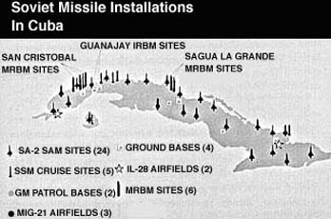
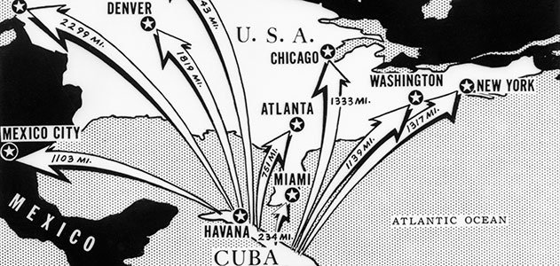
Aftermath The crisis was a tactical victory for the Soviets but a strategic loss. They had been seen backing down, and the attempt to gain strategic parity had failed, to the anger of the Soviet military commanders. Khrushchev's fall from power a few years later can be partially linked to Politburo embarrassment at both Khrushchev's backing down from the Americans and Khrushchev's creation of the crisis by deciding to install missiles in Cuba in the first place.
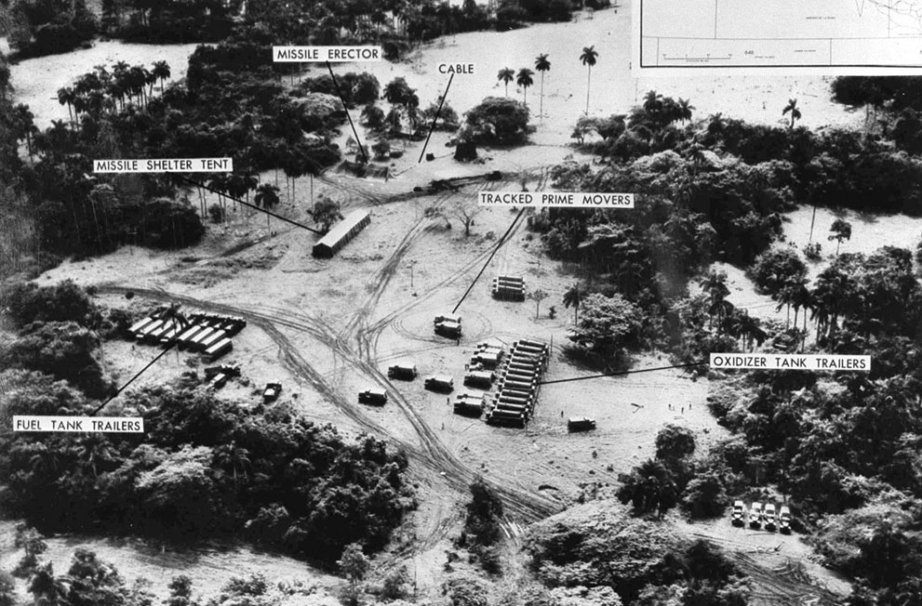

Cuban Missile Crisis Rubric
- Title
- Date
- Picture
- What was the CMC all about?
- What could have happened if there had been no solution/agreement?

Berlin Wall Falls
The Berlin Wall was a long wall isolating West Berlin from the surrounding territory of East Germany. It existed from 1961 until 1989.
In 1987 President Ronald Reagan gave a speech in Berlin where he asked the leader of the Soviet Union, Mikhail Gorbachev, to "Tear down this Wall!"
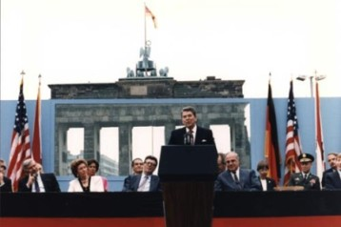
Around that time the Soviet Union was beginning to collapse. They were losing their hold on East Germany. A few years later on November 9, 1989 the announcement was made. The borders were open and people could freely move between Eastern and Western Germany. Much of the wall was torn down by people chipping away as they celebrated the end to a divided Germany. On October 3, 1990 Germany was officially reunified into a single country.
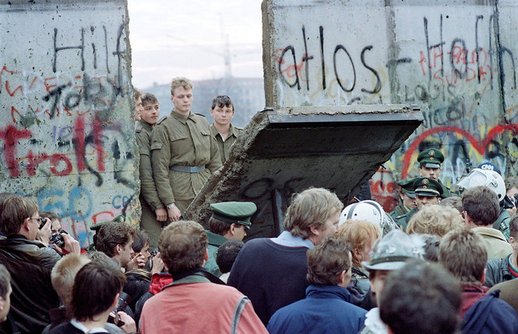
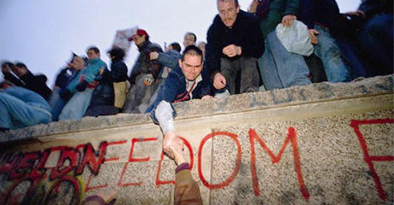

Berlin Wall Falls Rubric
- Title
- Date
- Picture
- Why did the wall exist?
- When, how, and why did the wall get torn down?

