KEY
Numbers =Rivers (1-12)
Letters = Cities (A-O)
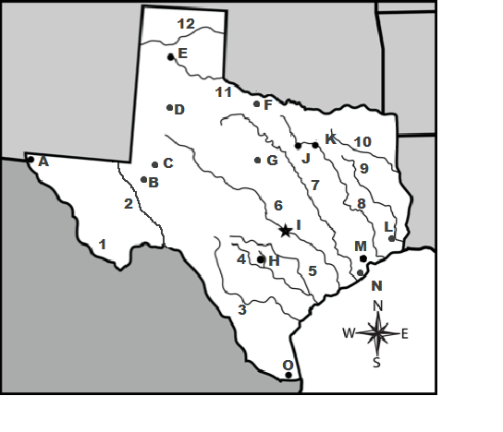
Cities and Rivers Quiz

